- Swap Two 8-bit Numbers
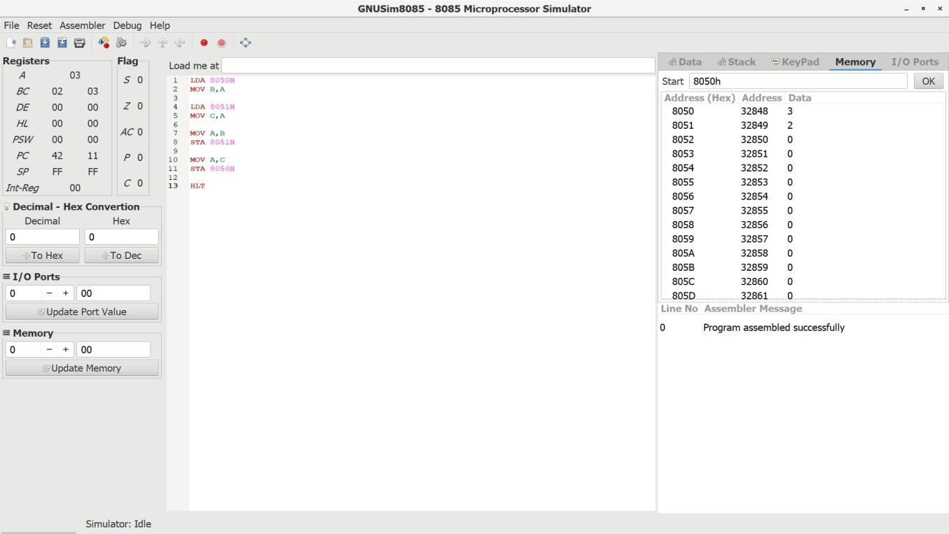

- 1's Complement of an 8-bit Number
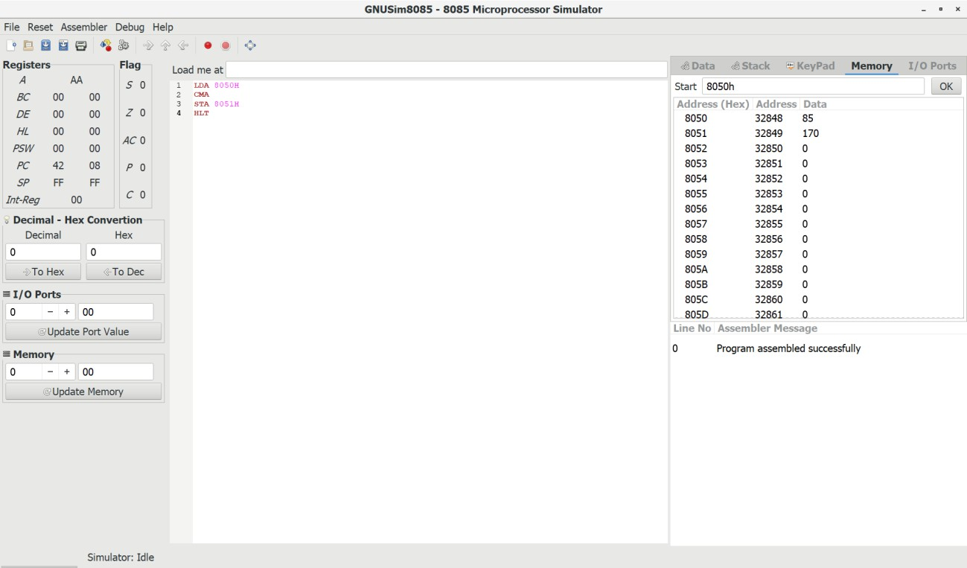

- 2's Complement of an 8-bit Number
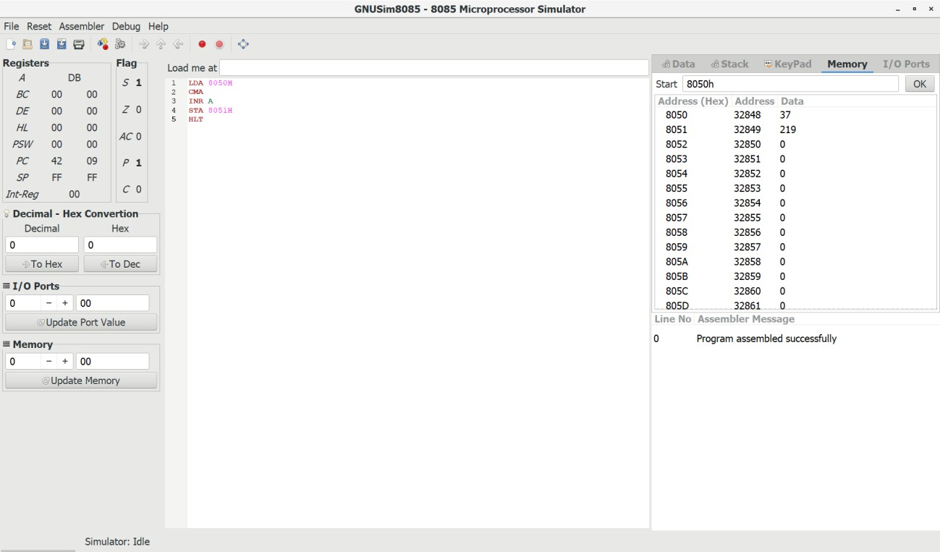

- Check Whether an 8-bit Number is Odd or Even
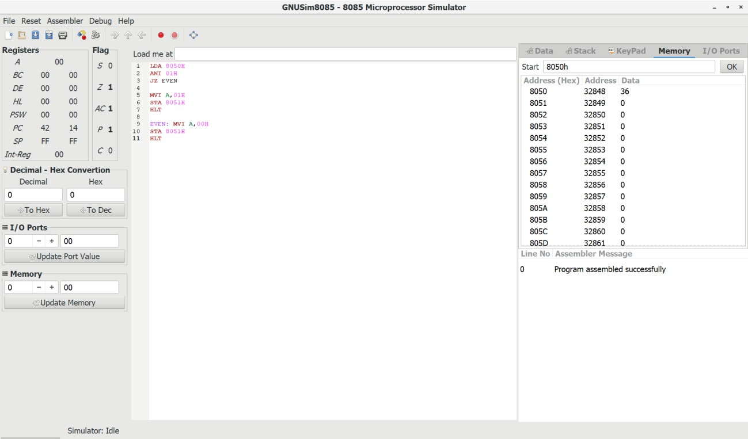

- Check Whether an 8-bit Number is Positive or Negative
